LAB Logbook
Lab 7
Week 7
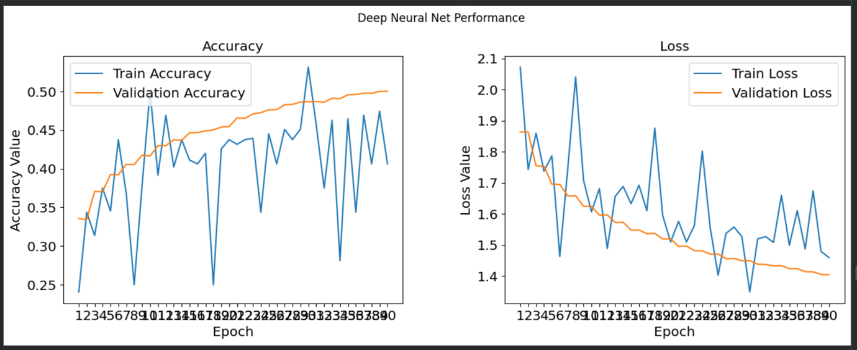
Loss vs Accuracy for VGG16
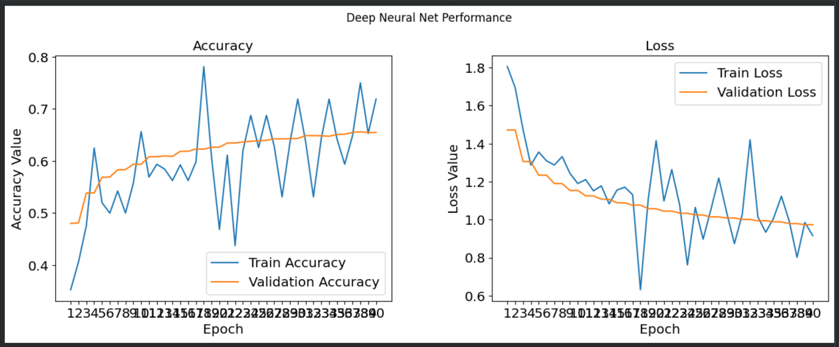
Loss vs Accuracy for VGG19
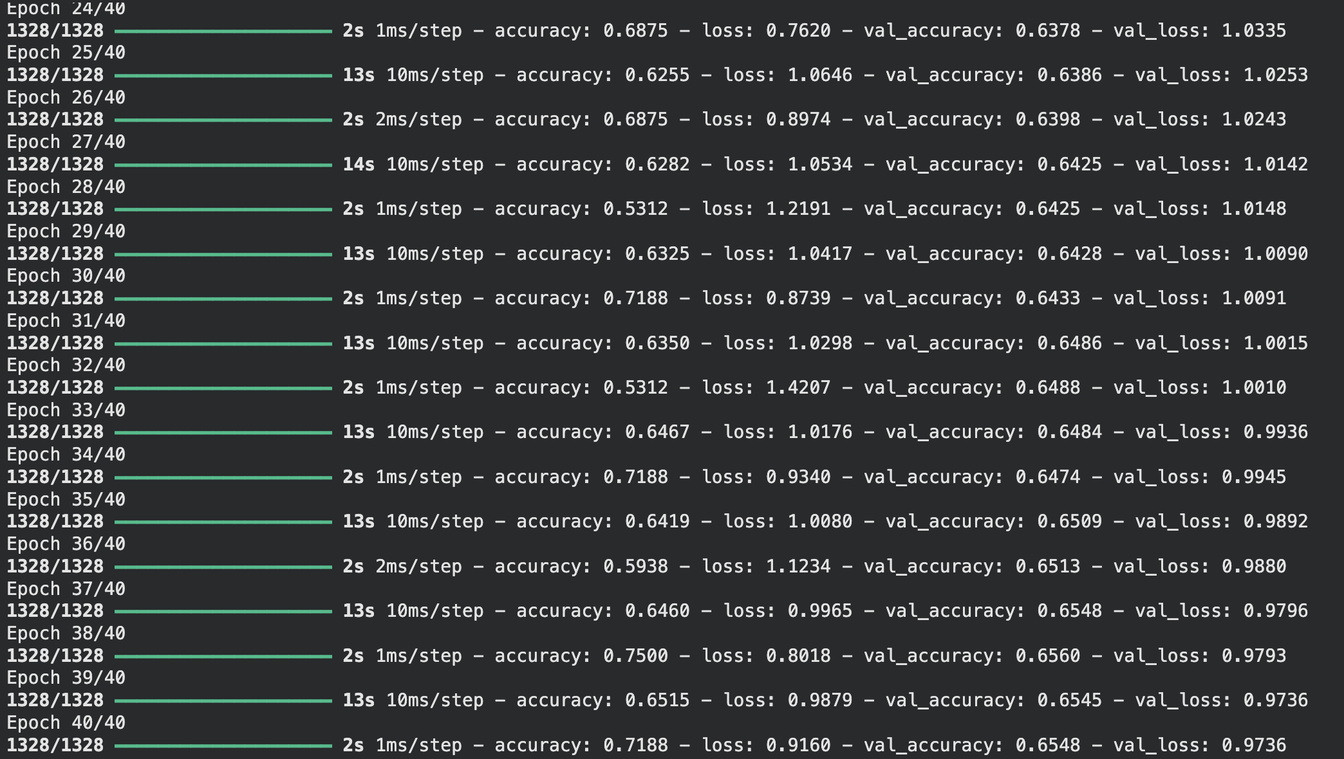
EPOCHS for VGG16
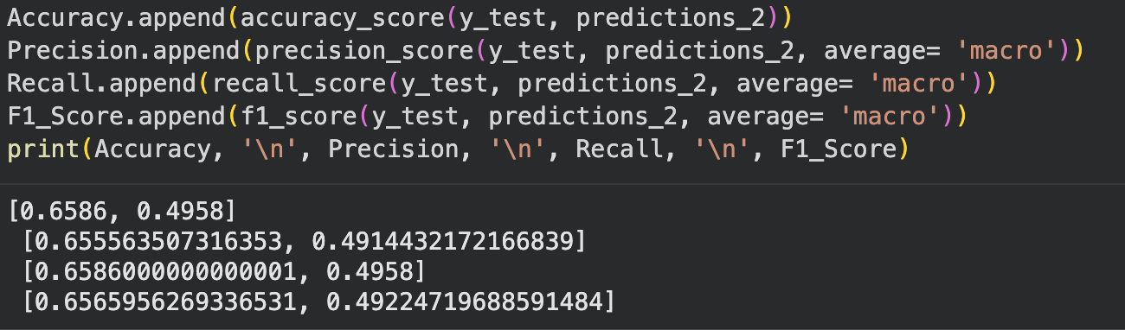
Performance Metrics for VGG16

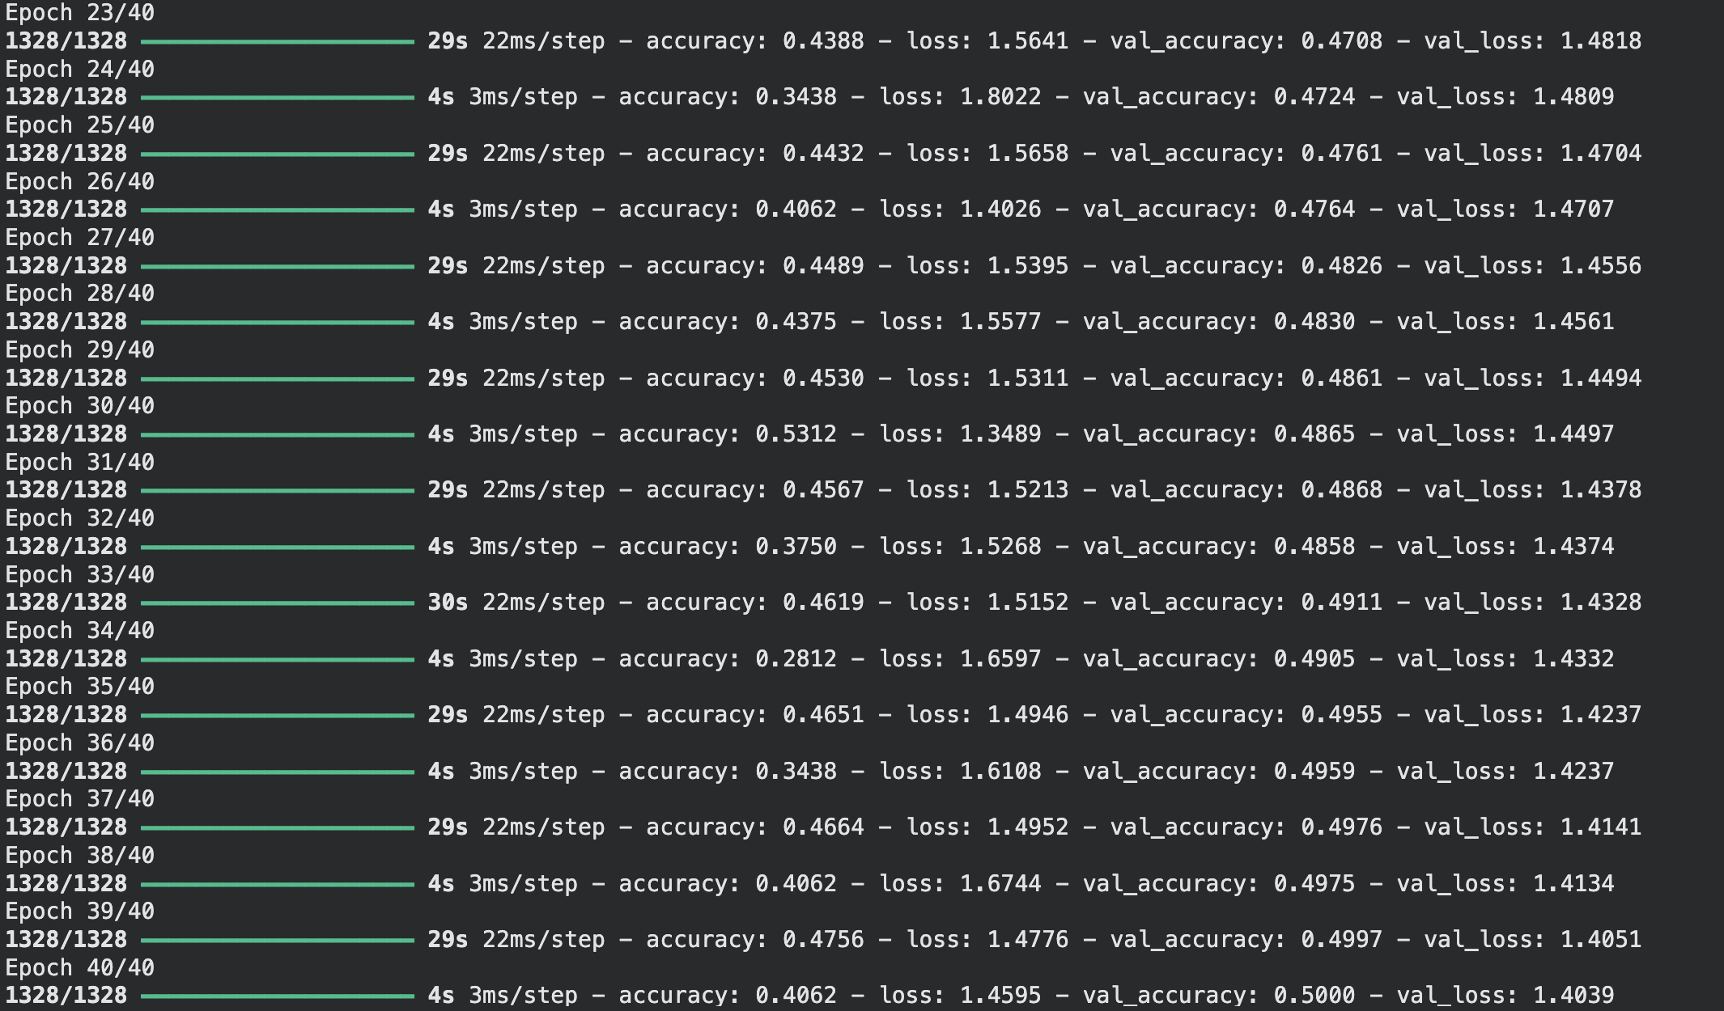
EPOCHS For VGG19
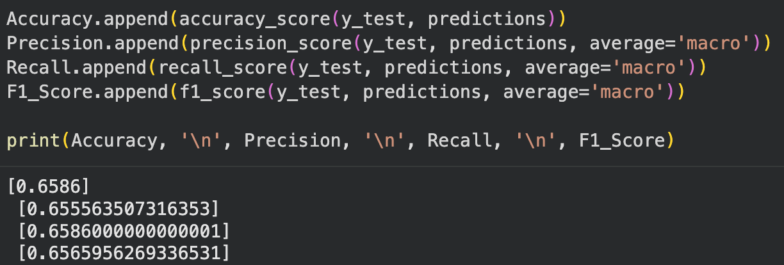
Performance Metrics for VGG19

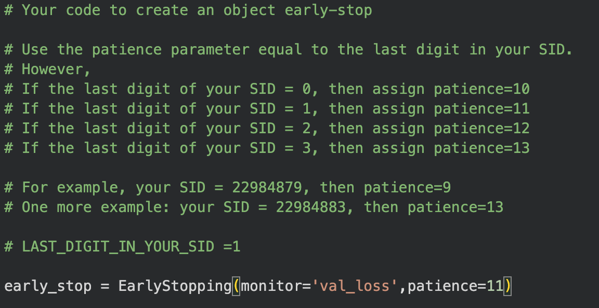
EarlyStopping Code
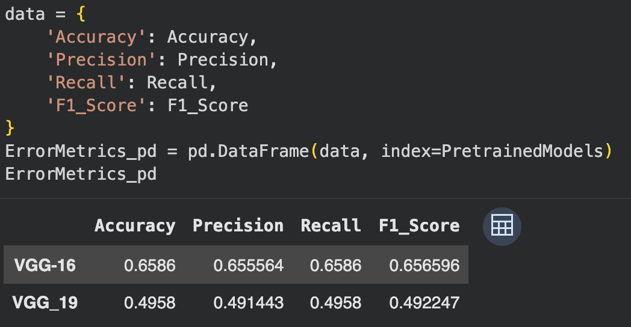
Performance Table

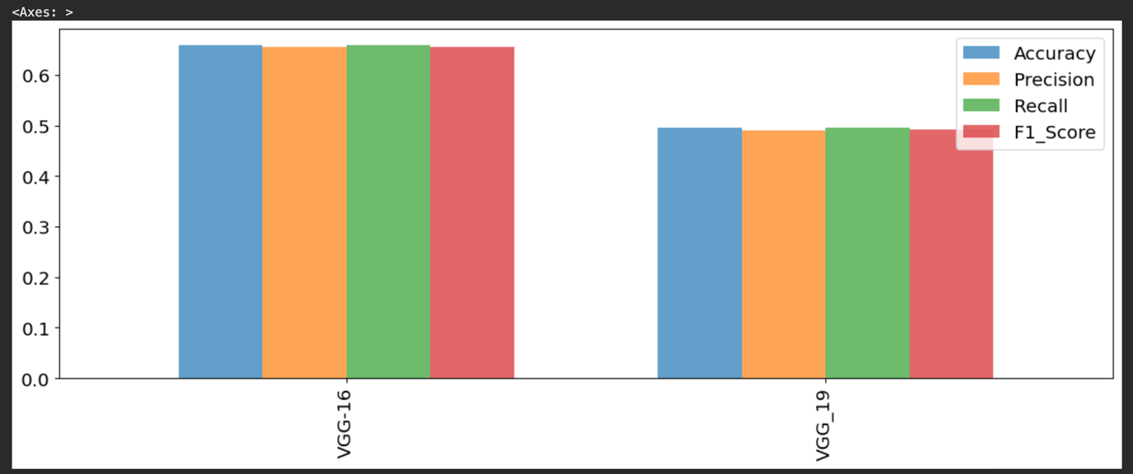
Performance histogram of VGG16 AND VGG19

Optional
Model Performance Comparison
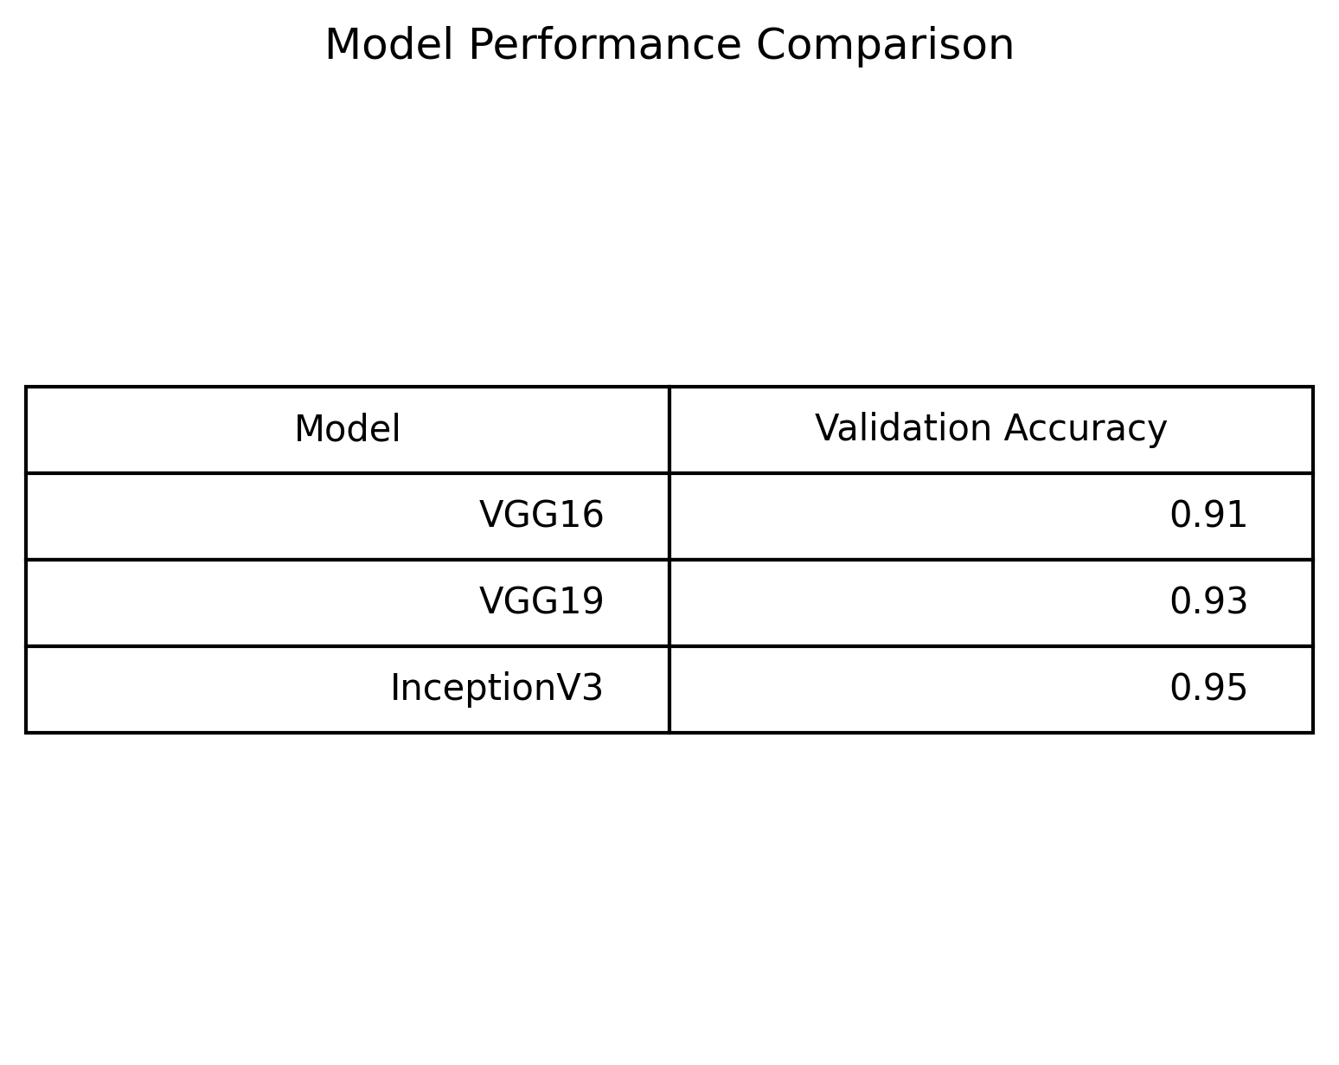
Validation Accuracy Comparison
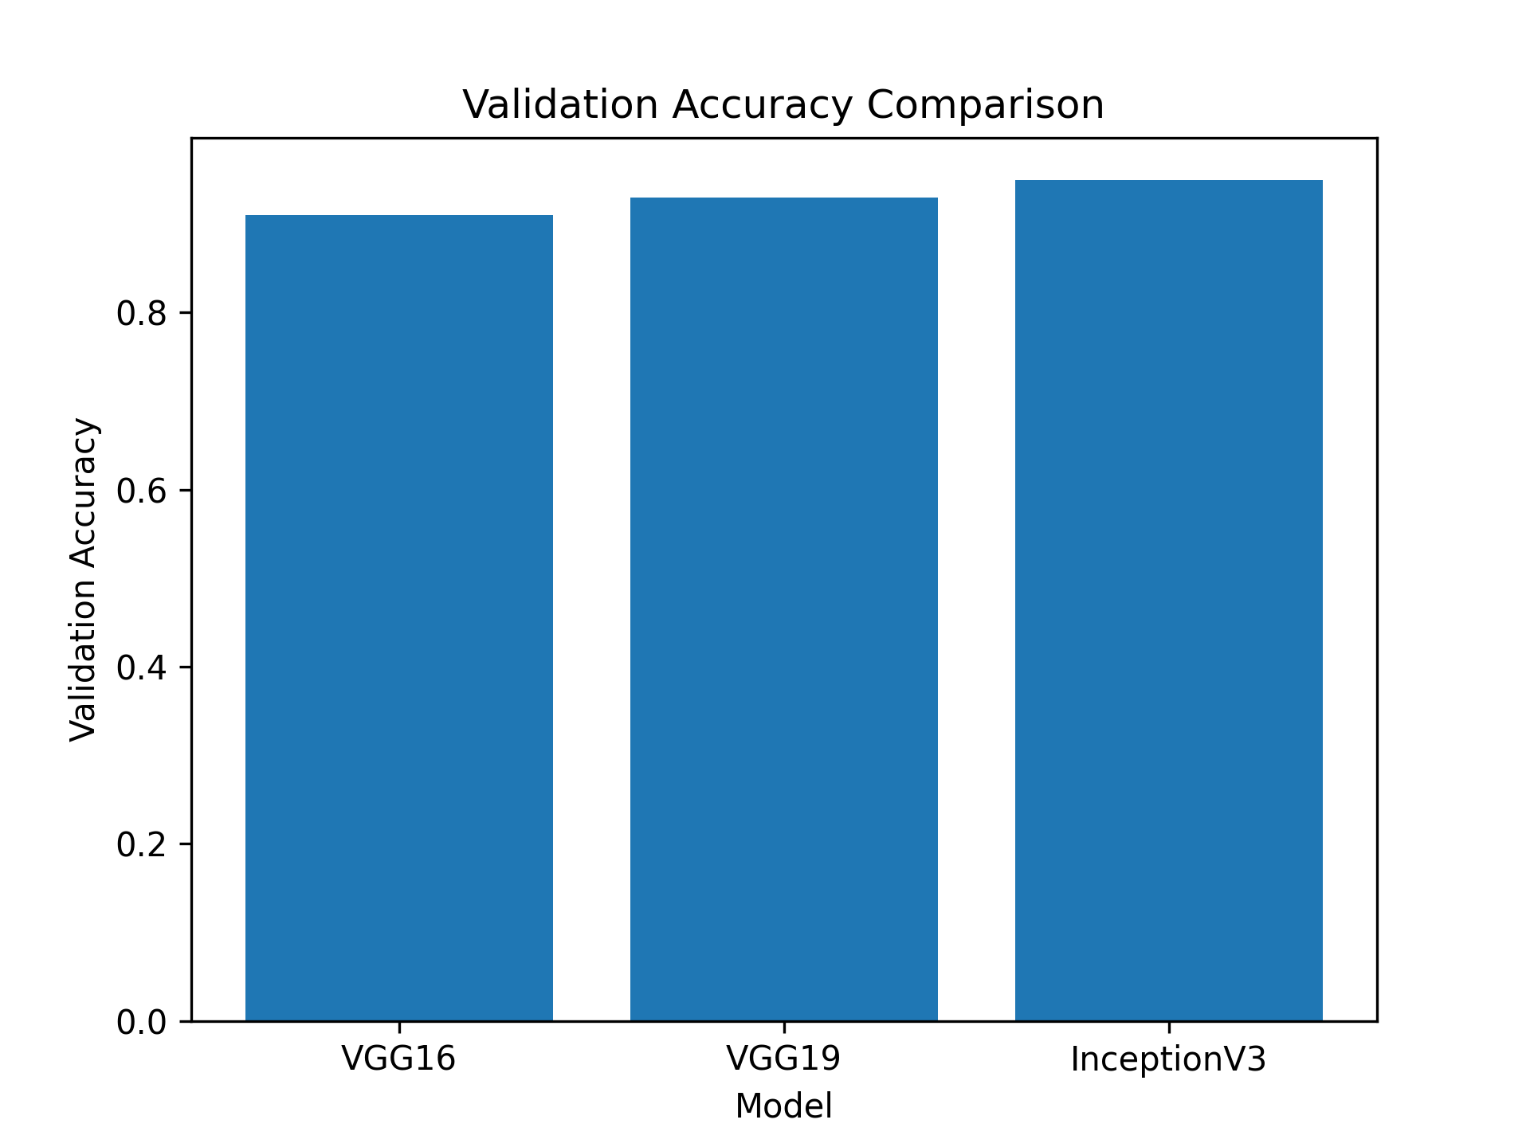
InceptionV3 Training vs Validation Accuracy
